
CATHOLIC JUNIOR COLLEGE
H
Preliminary Examination 2010
Higher 2

CANDIDATE
NAME
CLASS
2
T

CHEMISTRY 9647

Paper 3 Free Response Questions 2 September 2010
2 hr
Additional Materials: Data Booklet
Writing Paper

READ THESE INSTRUCTIONS CAREFULLY
Write your name and class on all the work you hand in.
Write in dark blue or black pen on both sides of the paper.
You may use a soft pencil for any diagrams, graphs or rough working.
Do not use staples, paper clips, highlighters, glue or correction fluid.

Answer any four questions, on the writing paper provided.
A Data Booklet is provided.
You are reminded of the need for good English and clear presentation in your answers.

The number of marks is given in brackets [ ] at the end of each question or part question.
At the end of the examination, detach this cover sheet and fasten it together with all the answer scripts of this paper securely together.
For Examiner’s Use
Q 1
Q 2
Q 3
Q 4
Q 5
80


This document consists of 7 printed pages and 1 blank page.

CJC Chemistry Department

© CJC 2010

BLANK PAGE
1 (a) The first ionisation energy of aluminium is 577 kJ mol⁻¹, while that of magnesium is 736 kJ mol⁻¹. Explain this observation. [2]

(b) When pure aluminium is left in air, it forms a protective coating. When this piece of aluminium is then placed in dilute hydrochloric acid or sodium hydroxide, initially there is no observable reaction but, after a few minutes, a colourless gas is evolved.
(i) Identify the protective coating and explain the observation as fully as you can. Write balanced equations for all reactions that occurred.

(ii) Hence suggest why solid formulations of drain cleaners are mostly made out of strong alkalis to which aluminium has been added.
[6]

(c) One of the products formed in (b) is used in the chlorination of methylbenzene. Identify this compound. Outline the mechanism for the chlorination of methylbenzene, showing clearly the role of this compound in the mechanism. [5]

(d) Recent studies are carried out to explore the use of (4-aminophenyl)ethanoic acid
(4-APEA) and its derivatives as possible drugs to treat chronic inflammation of the intestines. 4-APEA may be synthesised from methylbenzene as follows.
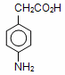
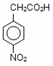
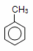
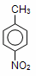
A
I
B
II
III
4-APEA

Draw the structural formulae of intermediate compounds A and B, and state clearly the reagents and conditions used in each of the stages I, II and III in the above synthesis of 4-APEA. [5]

(e) Oil spills are a waste of valuable resources and cause environmental problems. Traditional sorbent materials also absorb water in addition to oil, and as a result are unable to stay afloat. However, a new sorbent material called ‘hydrophobic aerogels’ has been developed to solve this problem. Due to its fluorine-containing groups, this new material is able to allow oil to be absorbed but not water.
––O––Si––CH₂––CF₃
By considering interactions between molecules, suggest why the ‘hydrophobic aerogels’ absorb oil but not water. [2]
[Total: 20]
- Potassium iodide and hydrogen peroxide have similar reducing properties.

(a) An aqueous solution containing 0.005 mol of bromine was added to 10.00 cm³ of
0.10 mol dm⁻³ sodium thiosulfate. 0.002 mol of potassium iodide was then added to the resulting solution to completely remove the unreacted bromine.

(i) Write an ionic equation for the reaction between potassium iodide and bromine.

- Calculate the number of moles of bromine which react with 1 mol of sodium thiosulfate.
[4]

(b) The decomposition of hydrogen peroxide to form water and oxygen follows first order kinetics. It was found that a certain solution of hydrogen peroxide undergoes complete decomposition to liberate 96 cm³ of oxygen gas.

(i) Given that 48 cm³ of oxygen gas was collected in 46 minutes, calculate the time taken for 72 cm³ of the gas to be evolved. (All volumes of oxygen gas are measured at the same temperature and pressure).

- Find the rate constant, k, for the reaction.
[3]

- The reaction between 2-bromobutane and aqueous sodium hydroxide when heated under reflux is represented by the equation below.

CH₃CHBrCH₂CH₃ + OH– → CH₃CH(OH)CH₂CH₃ + Br –

Experiments were conducted by mixing varying concentrations of the reactants. The results are given in the table below.

Experiment | [CH₃CHBrCH₂CH₃]  / mol dm⁻³ | [OH–]  / mol dm⁻³ | Initial rate of reaction  / mol dm⁻³ min⁻¹
1 | 0.0012 | 0.10 | 0.024
2 | 0.0030 | 0.10 | 0.060
3 | 0.0072 | 0.60 | 0.144

- Determine the order of reaction with respect to 2-bromobutane and sodium hydroxide. Hence, state the rate equation.

- Calculate the rate constant, stating the units clearly.

- Describe the type of mechanism involved.
[8]

- Another experiment is carried out using 2-bromobutane and ethanolic sodium hydroxide. State the type of reaction that would occur and draw the structures of all the possible organic products formed, including stereoisomers. [3]

- Describe a chemical test to distinguish between 2-bromobutane and bromobenzene.
[2]
[Total: 20]
3 Use of the Data Booklet is relevant to this question.

Water containing iron(II) compounds is known as ‘clear water’ because it appears colourless. However, when water seeps through iron-bearing soil or passes through corroded iron water pipes, it may become coloured. ‘Red water’ refers to water containing iron(III) compounds.

When ‘red water’ is used in laundry, iron stains can be formed on clothes.

(a) Explain why iron(III) compounds are coloured. [3]

(b) The standard electrode potential of the Fe³⁺(aq)/Fe²⁺(aq) half-cell relative to the standard hydrogen electrode is 0.77 V. Predict, with reasons, how the electrode potential will change if the following are added to the Fe³⁺(aq)/Fe²⁺(aq) half-cell:
(i) ‘red water’

(ii) pure water
[4]

- Explain the following observations, giving relevant equations:

- When ‘red water’ is added to aqueous KI, the solution turns brown.

- When ‘red water’ is first added to aqueous KCN, a ligand replacement reaction takes place and an orange solution is formed. Upon the addition of aqueous KI, the orange solution remains.
[4]

(d) Stain removers containing reducing agents can be used to remove iron stains caused by ‘red water’.

- Explain, with the use of E^{ө} values, why sodium ethanedioate is effective in removing iron stains under standard conditions. Hence, write the balanced equation for the reaction involved.

The standard redox potential for the half cell reaction is

2CO₂ (aq) + 2e⁻ C₂O₄²⁻(aq) E^{ө} = -0.49 V

- Suggest why sodium ethanedioate is preferred over ethanedioic acid as an iron stain remover.

- Would you recommend stain removers containing hydrogen peroxide as effective iron stain removers under standard conditions? Explain.
[5]

(e) Three unknown iron(III) complexes A, B and C with the general formula FeCl₃.6H₂O, in which the coordination number is 6, have been prepared.

When 0.01 mol of each complex is treated separately with aqueous silver nitrate, the following masses of white precipitate are obtained.

Complex | A | B | C
Mass of white precipitate formed / g | 4.30 | 1.44 | 1.44

(i) Deduce the structural formula of complex A.

(ii) B and C are geometric isomers of each other. Using the information above, draw the structures of complexes B and C.
[4]
Fe
[Total: 20]

4 (a) Compounds F and G have the same molecular formula C₁₀H₁₁NO₂. Both compounds react with Tollens’ reagent, but only G reacts with Fehling’s solution.
The structure of G is:
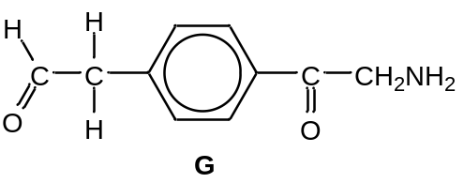

When F is heated with aqueous sodium hydroxide, compound H and gas I, which turns red litmus paper blue, is evolved. G reacts with excess chloromethane to form a salt J which can be isolated. J forms a white precipitate immediately on addition to aqueous silver nitrate.

When heated with acidified KMnO₄, H gives the acid L which has the structure shown below.

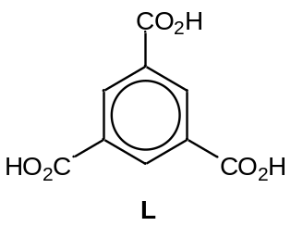

Deduce the identity of compounds F, H, I, J and explain the chemistry of the reactions involved.
[8]

(b) Explain the difference in basicity between ethylamine, CH₃CH₂NH₂ and phenylamine, C₆H₅NH₂. [3]

(c) The hormone insulin is responsible for regulating the blood glucose level in our body. Insulin consists of two polypeptide chains, which are made up of 21 and 30 amino acid residues respectively. Each chain coils to form short sections of alpha helix and the two chains are held together mainly by the interactions formed between the cysteine residues.

- Give the name and displayed formula of the linkage between amino acid residues in insulin.

- Describe how the polypeptide chain is held in the structure of an alpha helix.

- The R-group of cysteine is (-CH₂SH). Illustrate the interaction formed between cysteine residues.

- Suggest how the addition of heavy metal ions can denature insulin.
[5]
(d) Another hormone, known as thyrotropin-releasing hormone (TRH), is a tripeptide with the following structure:
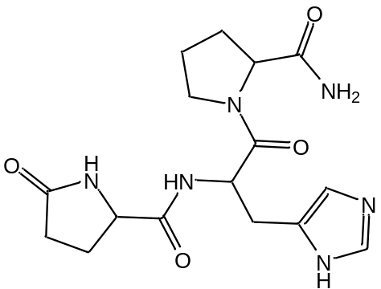
TRH
State the reagents and conditions required for the hydrolysis of this hormone into its constituent amino acids and give the structures of the three amino acids formed from its hydrolysis. [4]
[Total: 20]

5 (a) In the preparation of iodoethane from ethanol, a student attempted to use concentrated nitric acid and solid potassium iodide to prepare the required reagent, hydrogen iodide, HI. During the experiment, he observed some formation of black precipitate and brown gas, NO₂, with a very low yield of HI formed, the other final product being water.

(i) Identify the black precipitate and suggest two balanced equations for the reaction of concentrated nitric acid with potassium iodide.

(ii) In an attempt to increase the yield of HI, the student added more concentrated nitric acid to the black precipitate. However, this resulted in the formation of iodic acid, HIO₃, with more brown gas, NO₂, and water produced.

Suggest a balanced equation for this reaction and state the type of reaction.

(iii) Suggest an alternative set of chemicals that is suitable for the synthesis of iodoethane from ethanol.

(iv) HI reacts fastest with alcohols, as compared to HBr and HCl, as iodide ion is the strongest nucleophile. Suggest why iodide ion is the strongest nucleophile.
[6]
(b) IPA, Dettol and TCP are three hydroxy compounds often used as disinfectants and antiseptics.
 | 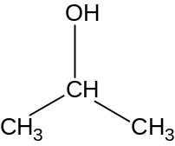 | 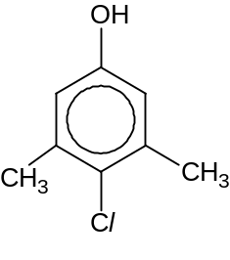 | 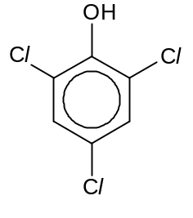
Common Name | IPA | Dettol | TCP
K_{a} / mol dm⁻³ | 7.94 x 10^{–18} | 1.99 x 10⁻¹⁰ | 6.46 x 10^{–7}

(i) Write a chemical equation to represent the acid dissociation of Dettol in water.

(ii) Calculate the pH of 0.20 mol dm⁻³ of Dettol.

(iii) Compare and explain the relative acidity of IPA and Dettol.

(iv) Explain why TCP is a stronger acid than Dettol.
[8]
(c) TCP can be made in the laboratory from phenol.

(i) State the reagents required, and give a balanced equation for this reaction.

(ii) Bottles of aqueous solutions containing IPA, Dettol and TCP were found without labels. Suggest a chemical test (stating reagents, conditions and observations) which can be used to distinguish the following pair of compounds:

I. TCP and Dettol

II. IPA and Dettol [6]
[6]
[Total: 20]

